Accessible Template Sampler
  - A sample of the most popular Accessible Word Templates fully optimized for use by people with visual disabilities.

Business
Retail sale flyer  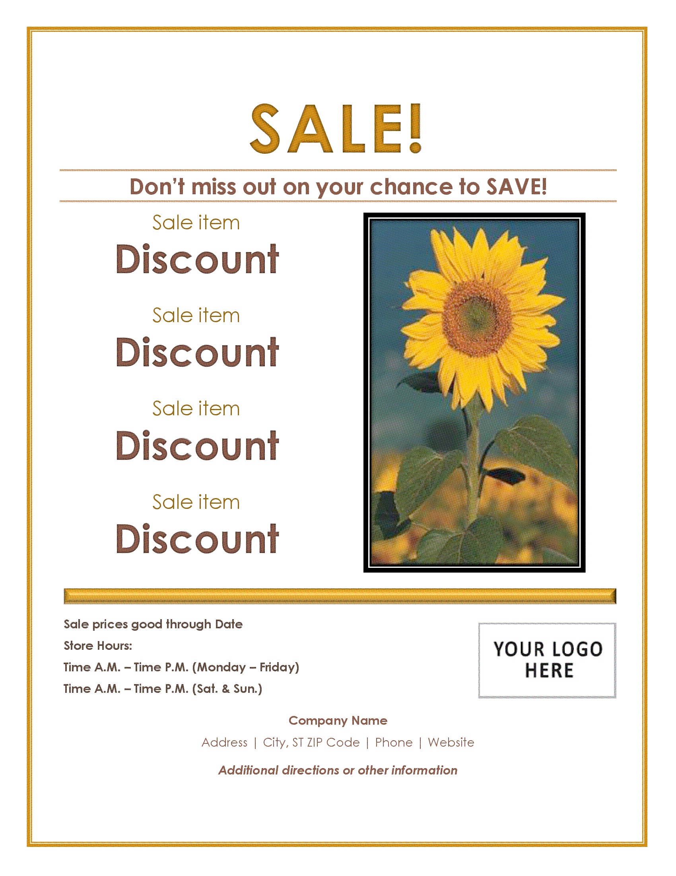  Customize this accessible and colorful flyer template to promote your sales event. It prints on one 8.5 x 11 inches page.  Download template | PTA agenda  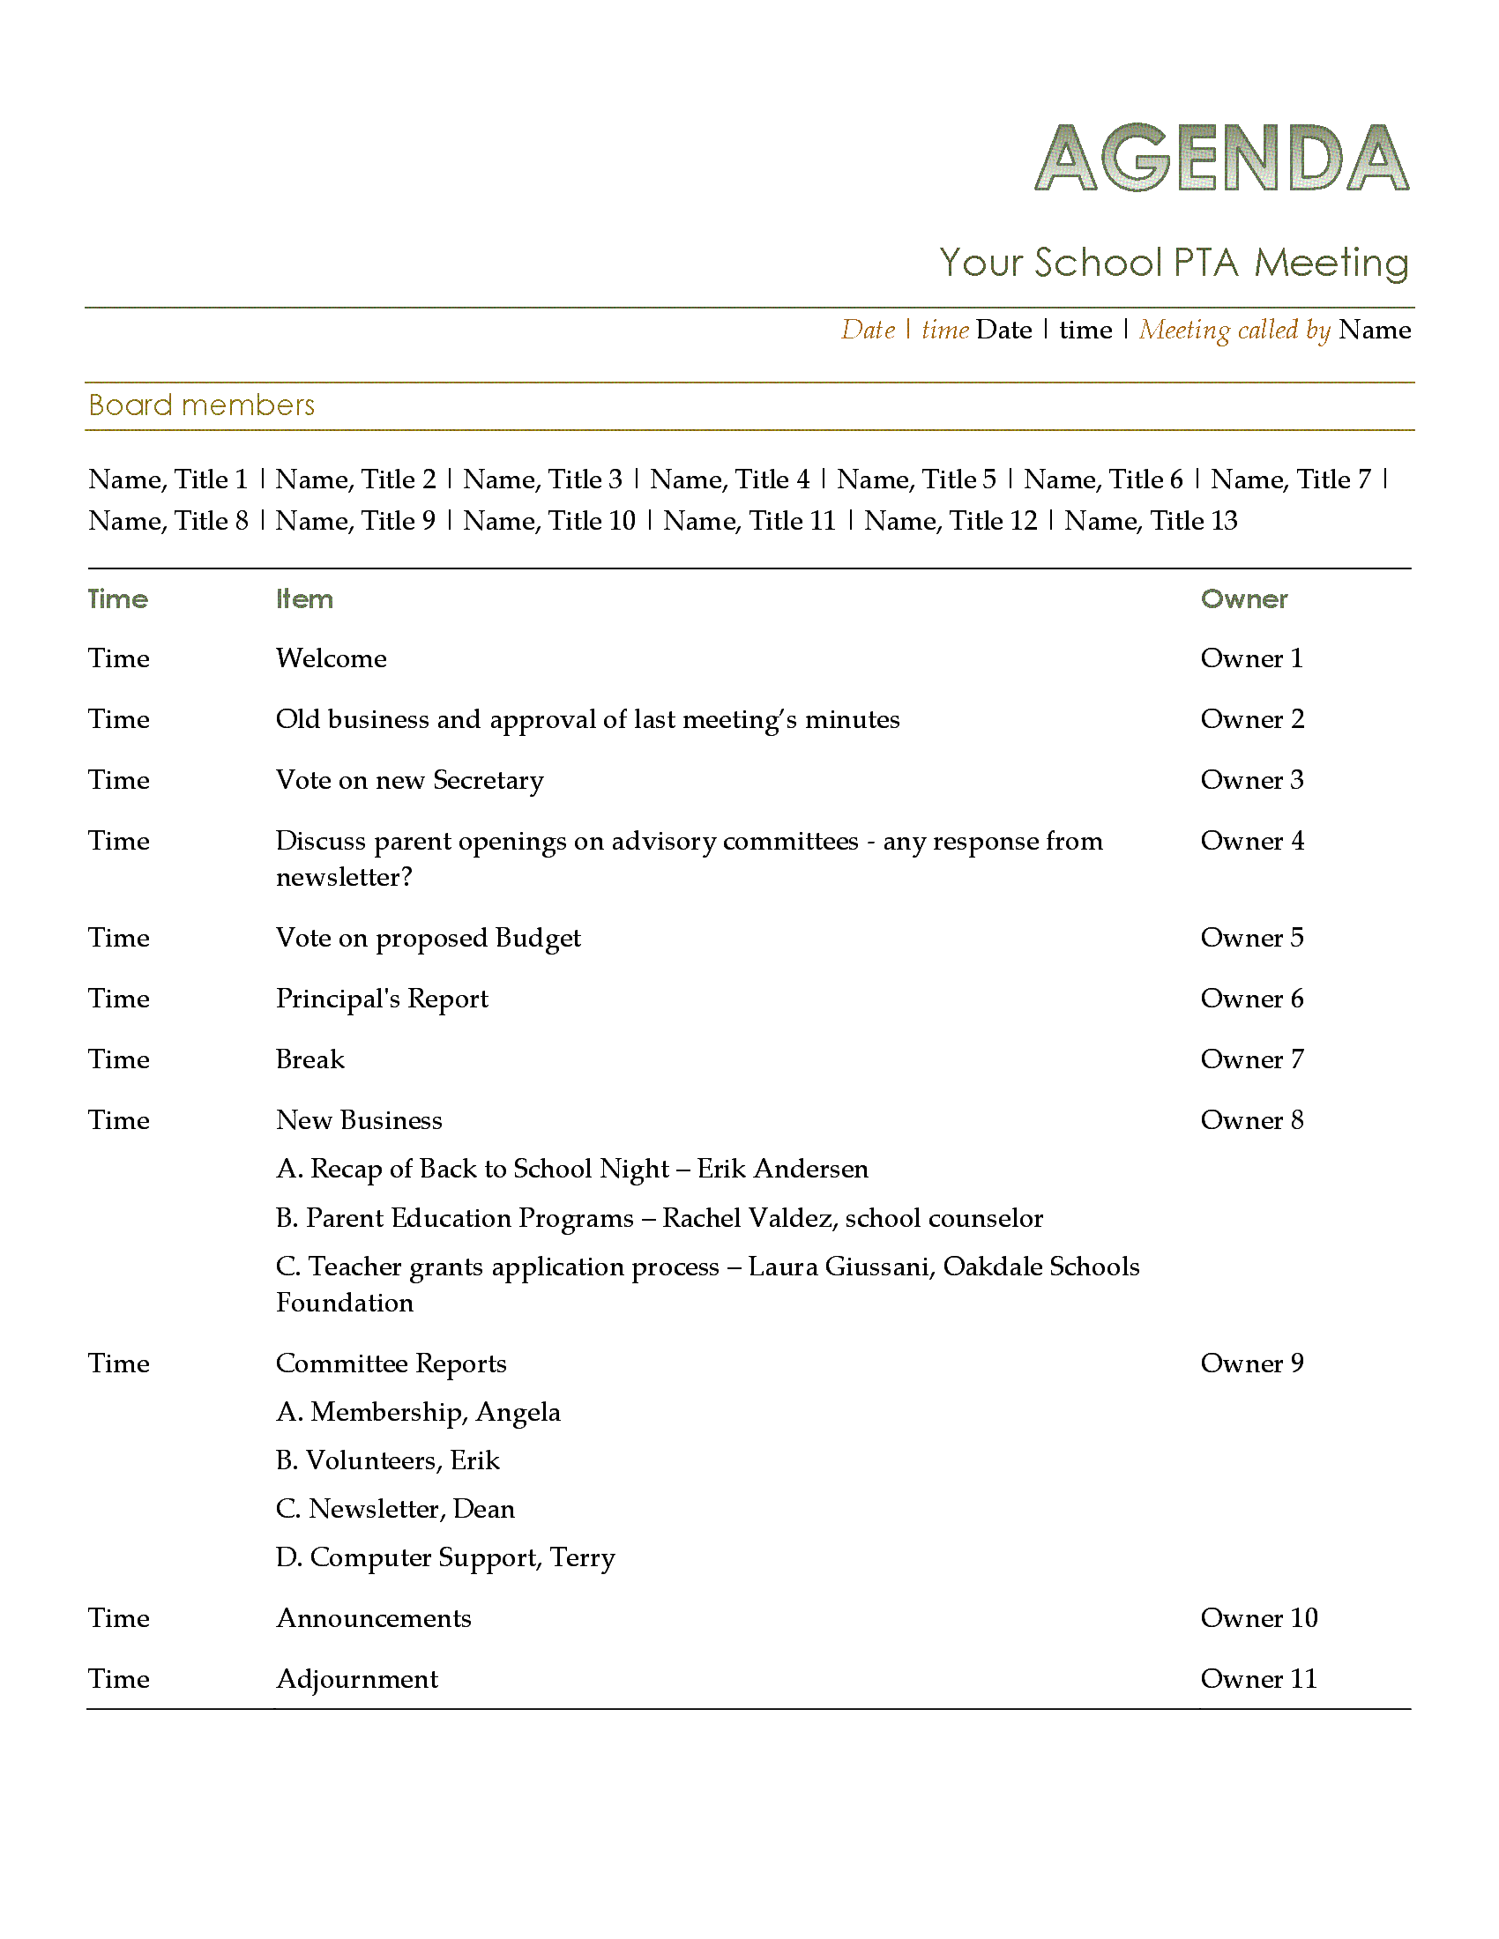  Plan your PTA meeting with this accessible agenda, listing talking points and times allotted for each.  Download template
Business flyer  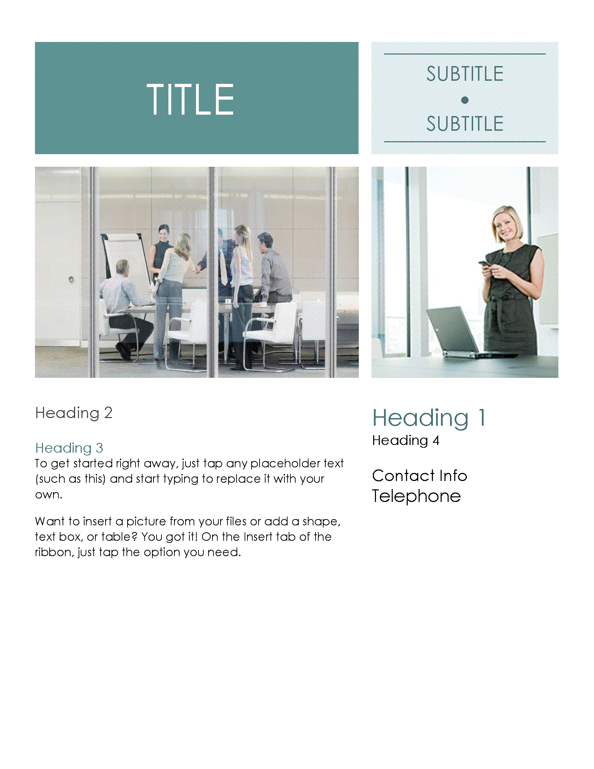  Use this accessible business flyer template to announce special events and for direct marketing or creating brand awareness.  Download template | Seasonal event flyer  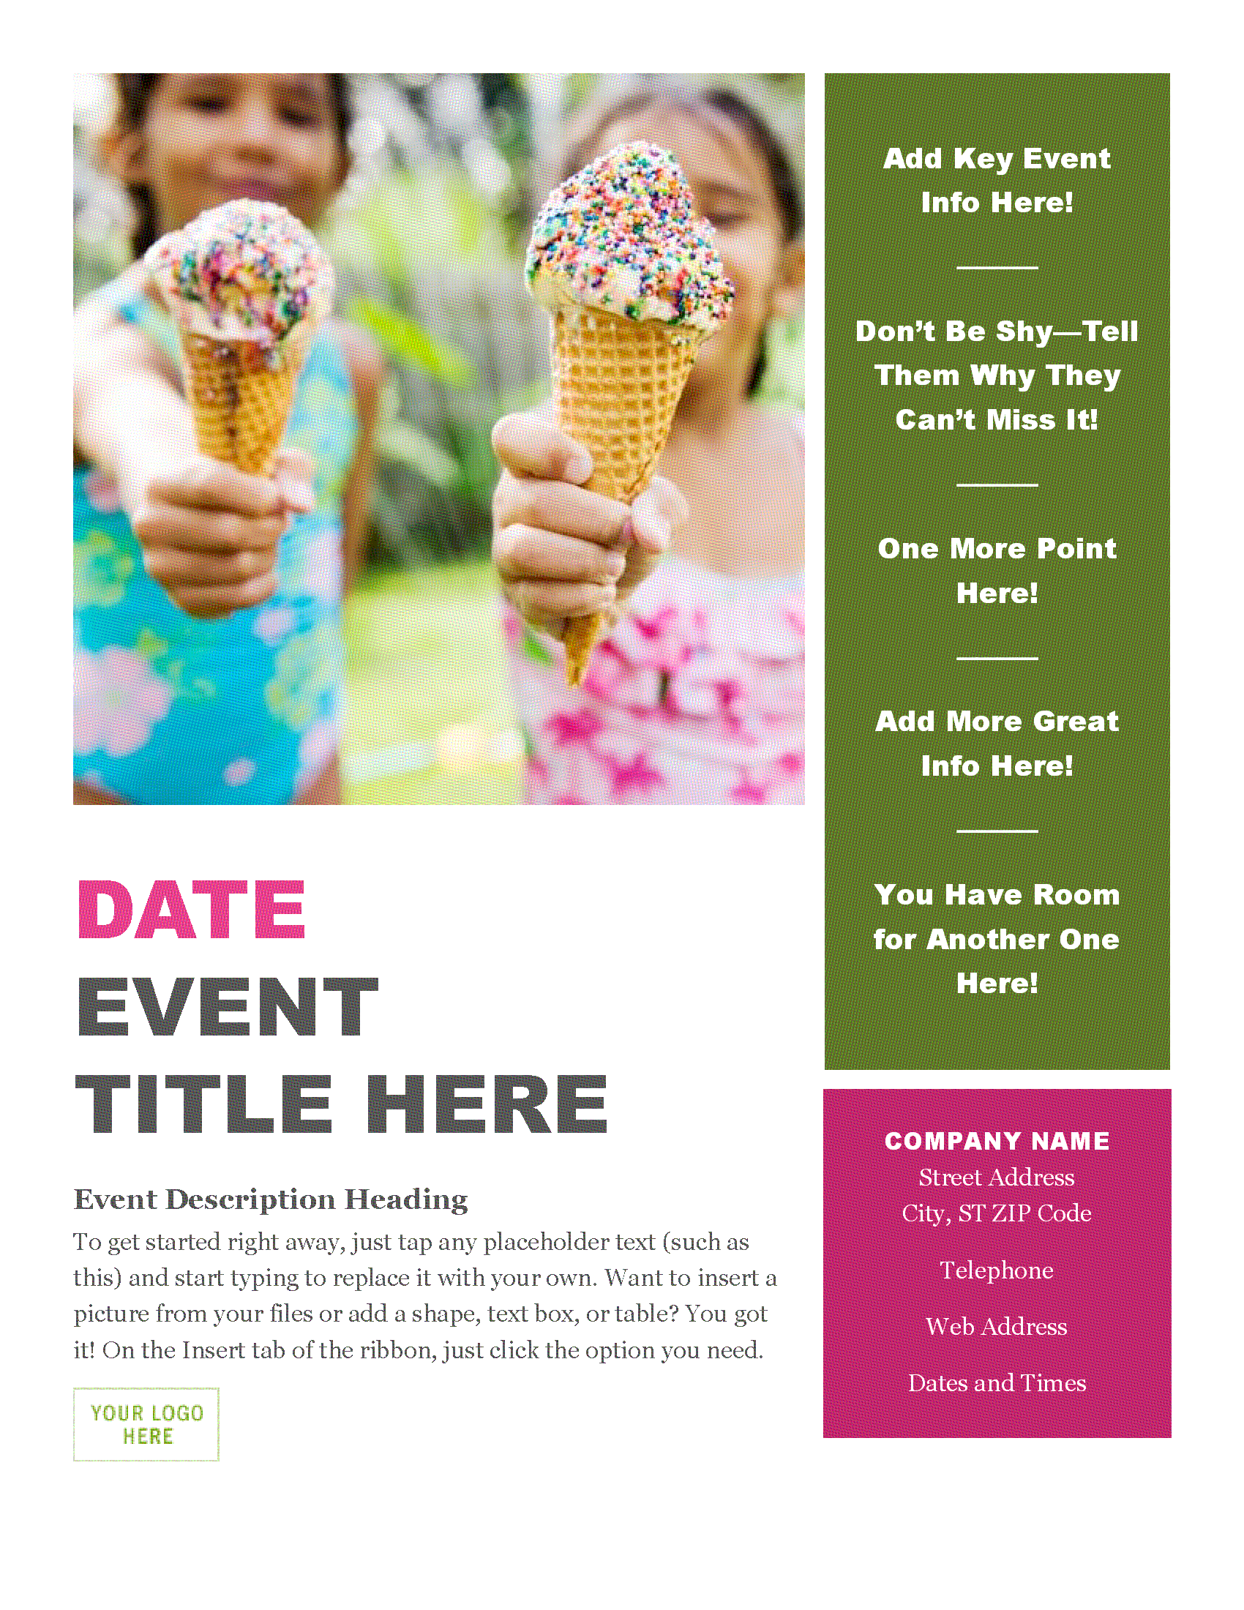  Let everyone know about your summer event with this color block designed seasonal flyer, which is an accessible template.  Download template

Birthday
Birthday invitation postcards  (2 per page)  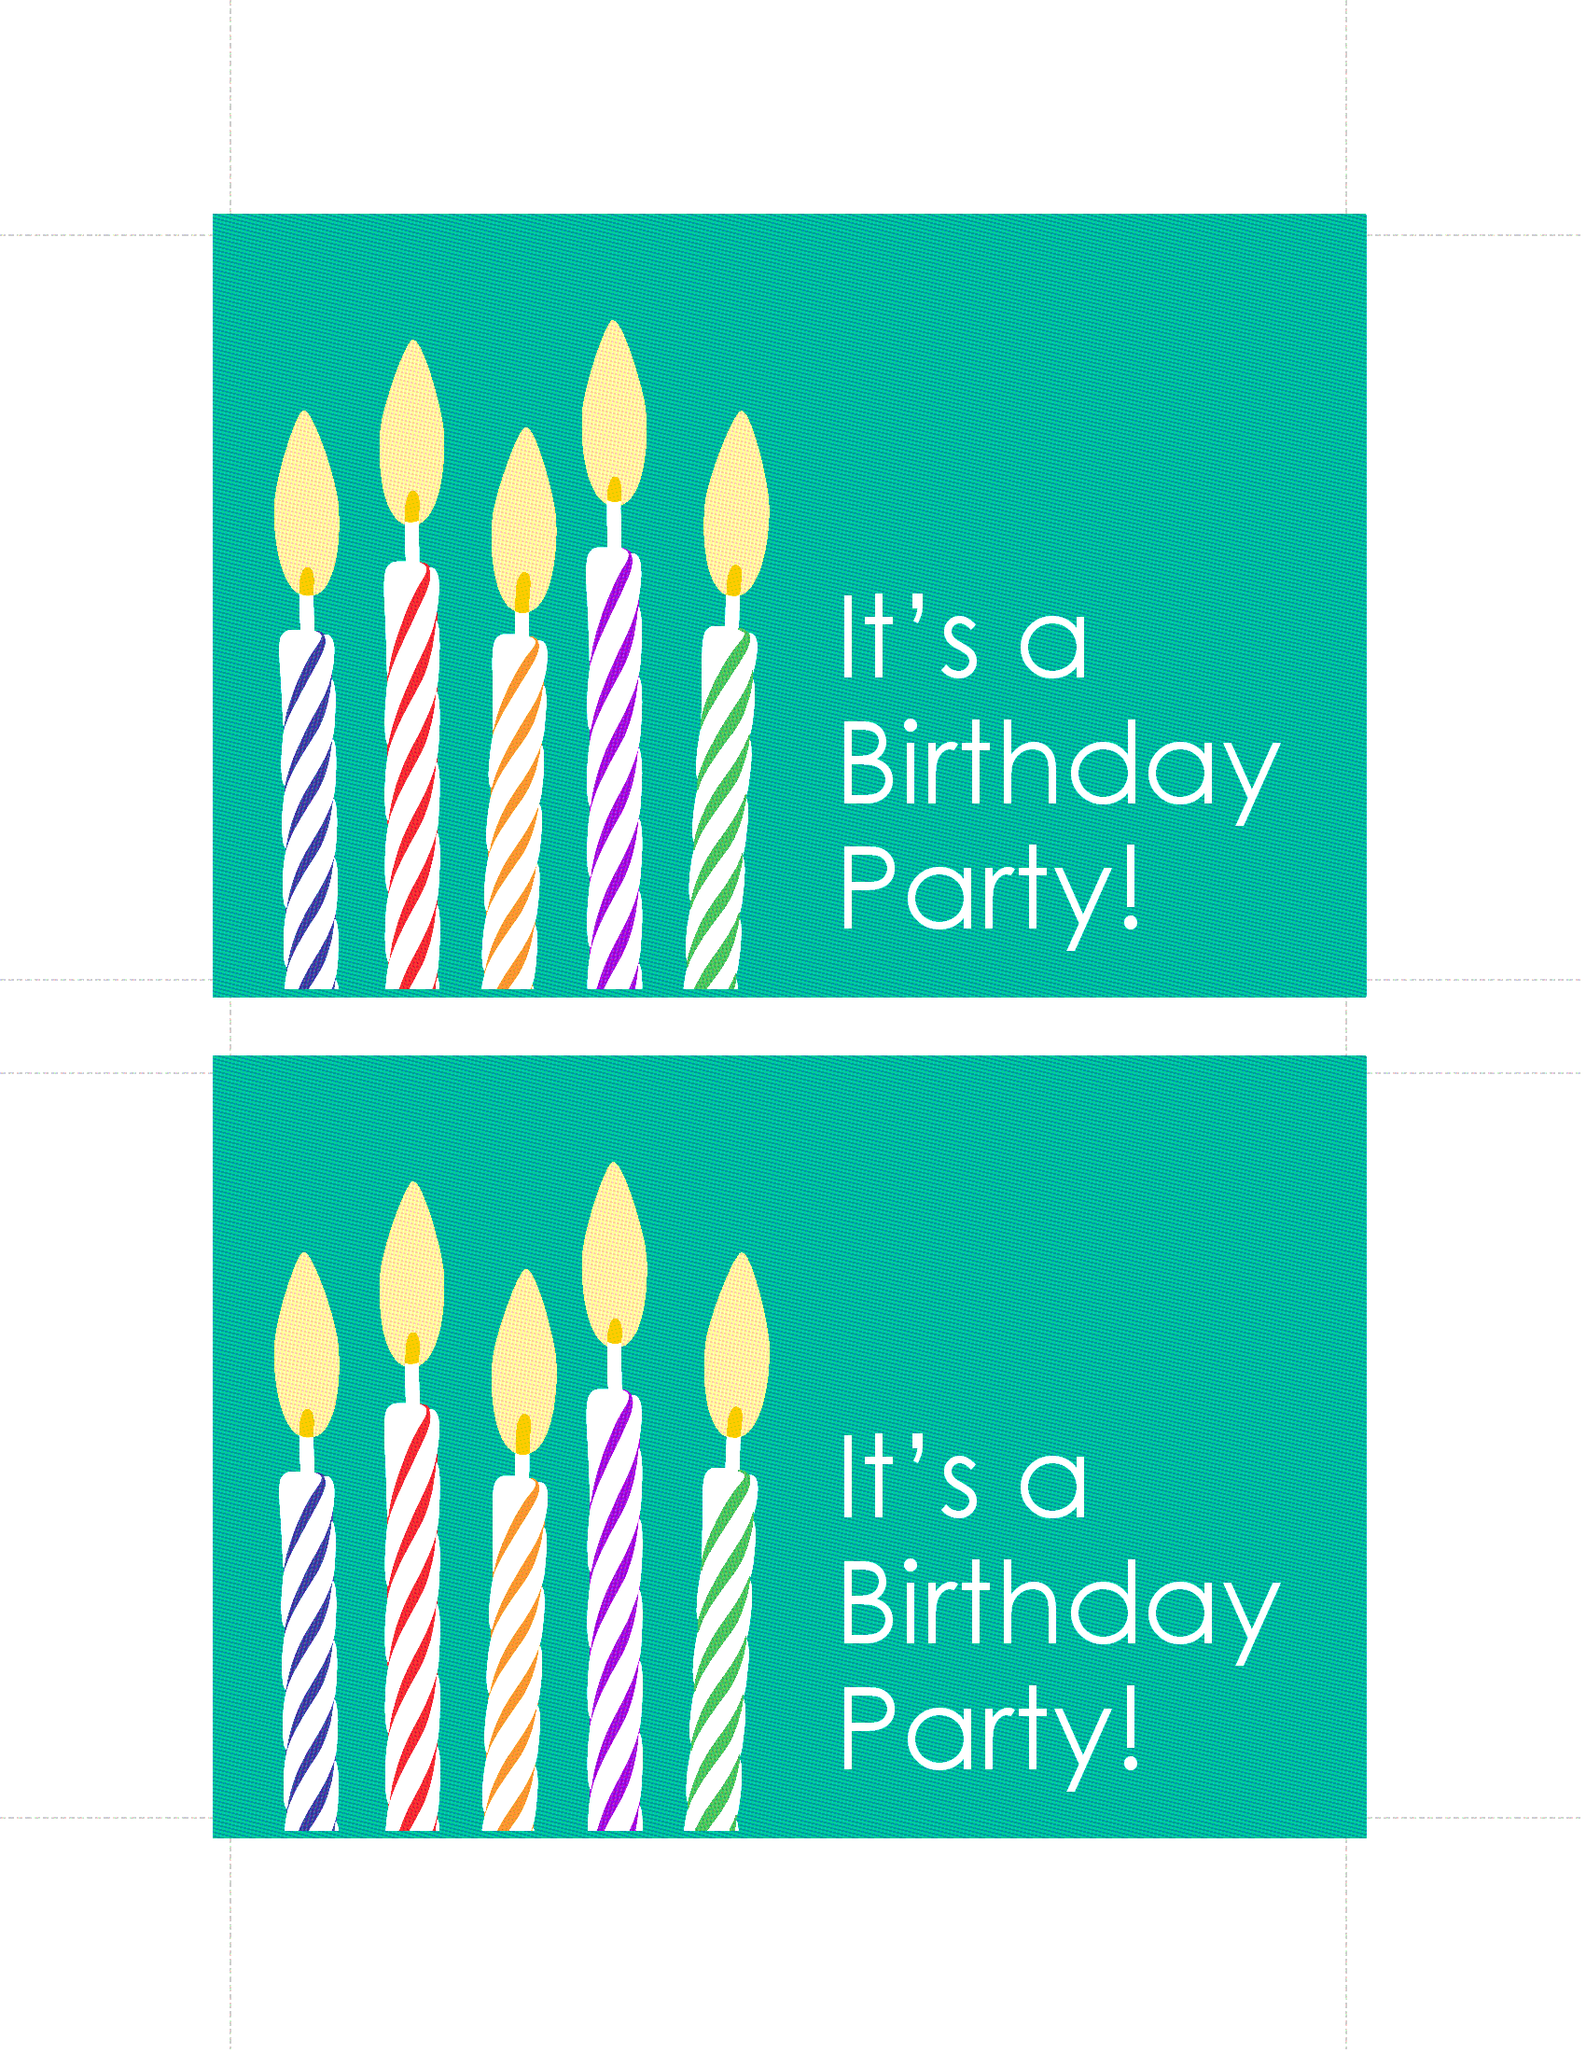  Use this cheerful postcard template to invite people to your upcoming birthday celebration. This accessible postcard is 4 x 6 inches.  Download template | Birthday cards  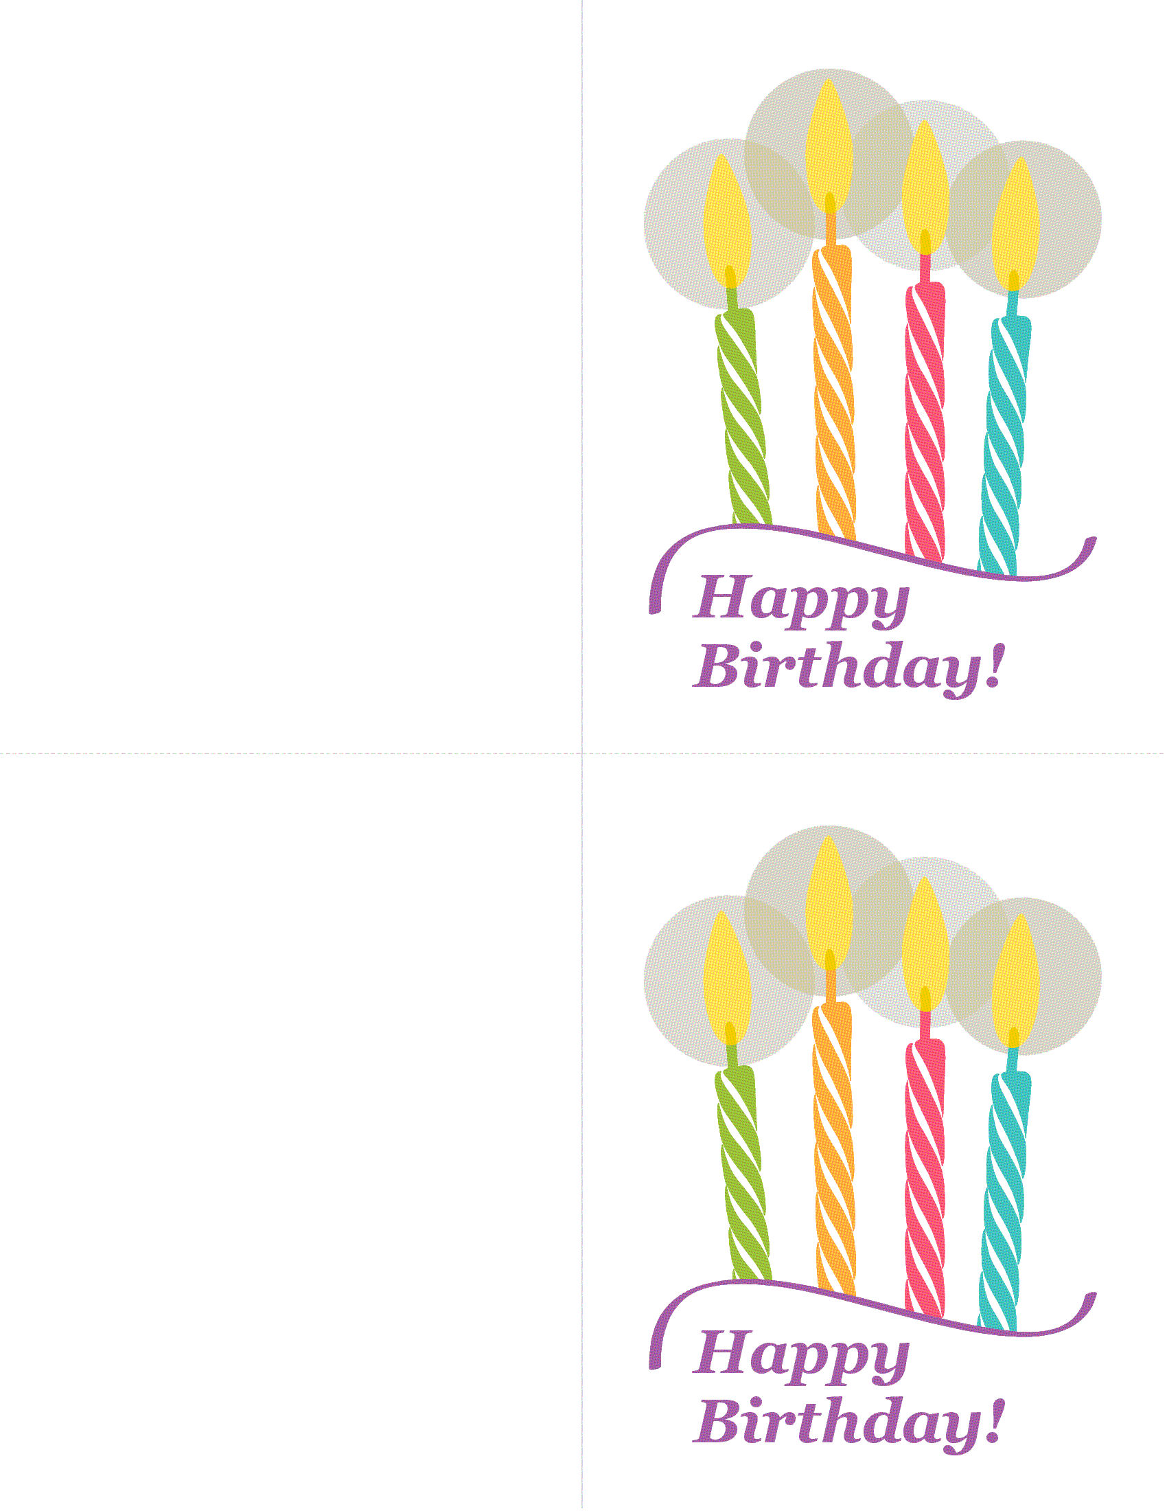  Send birthday cheer with this colorful and accessible greeting card. Two folded with two  4.25 x 5.5 inches cards per page.  Download template
Birthday poster  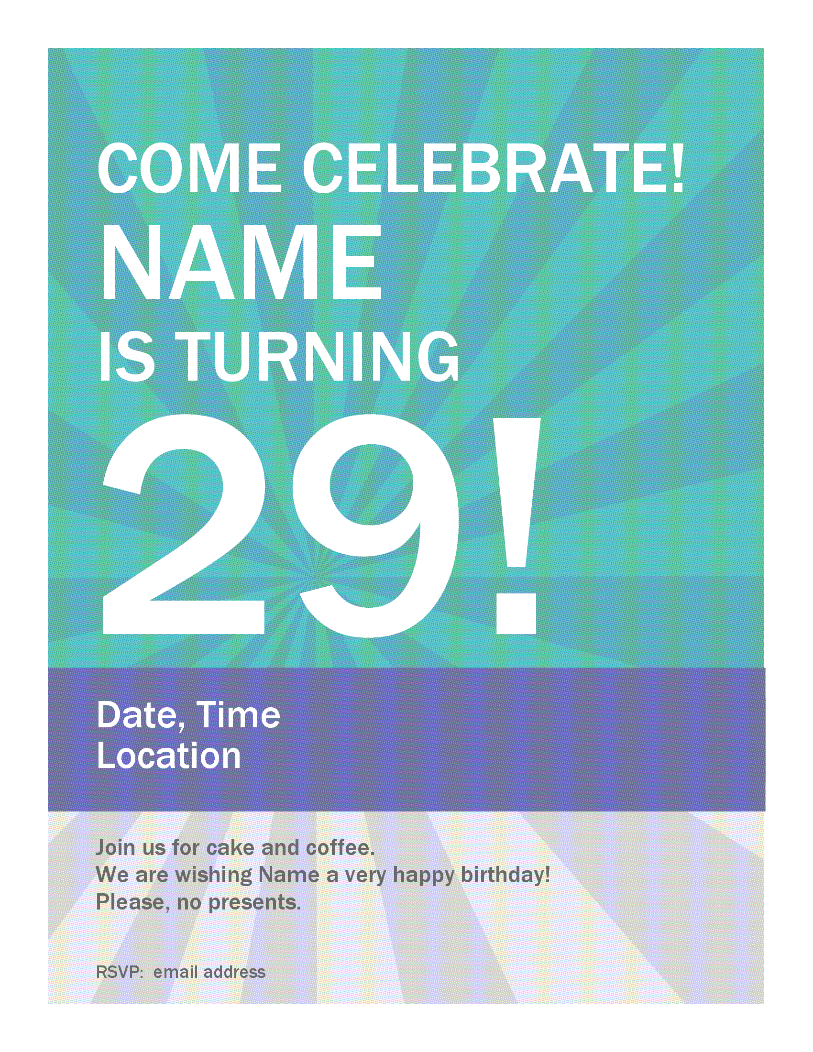  Use this accessible birthday celebration poster template to spread the word about a work party or personal event.  Download template | Birthday certificate note card  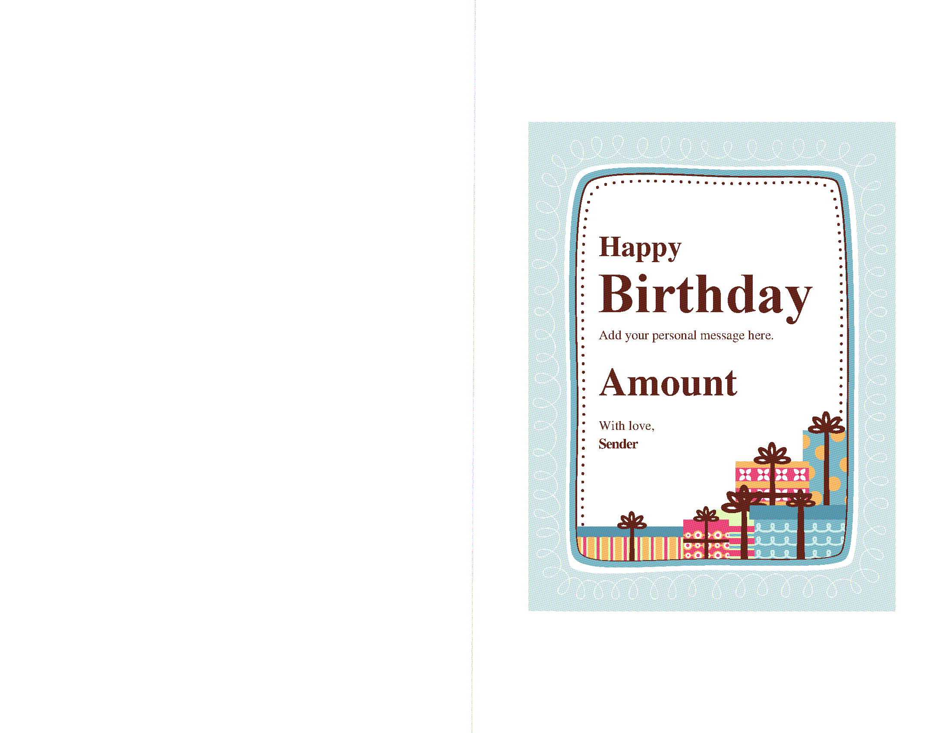  Print a custom birthday gift certificate with this accessible and handy template. Just fill in details and print.  Download template

Label
Floral personal business cards  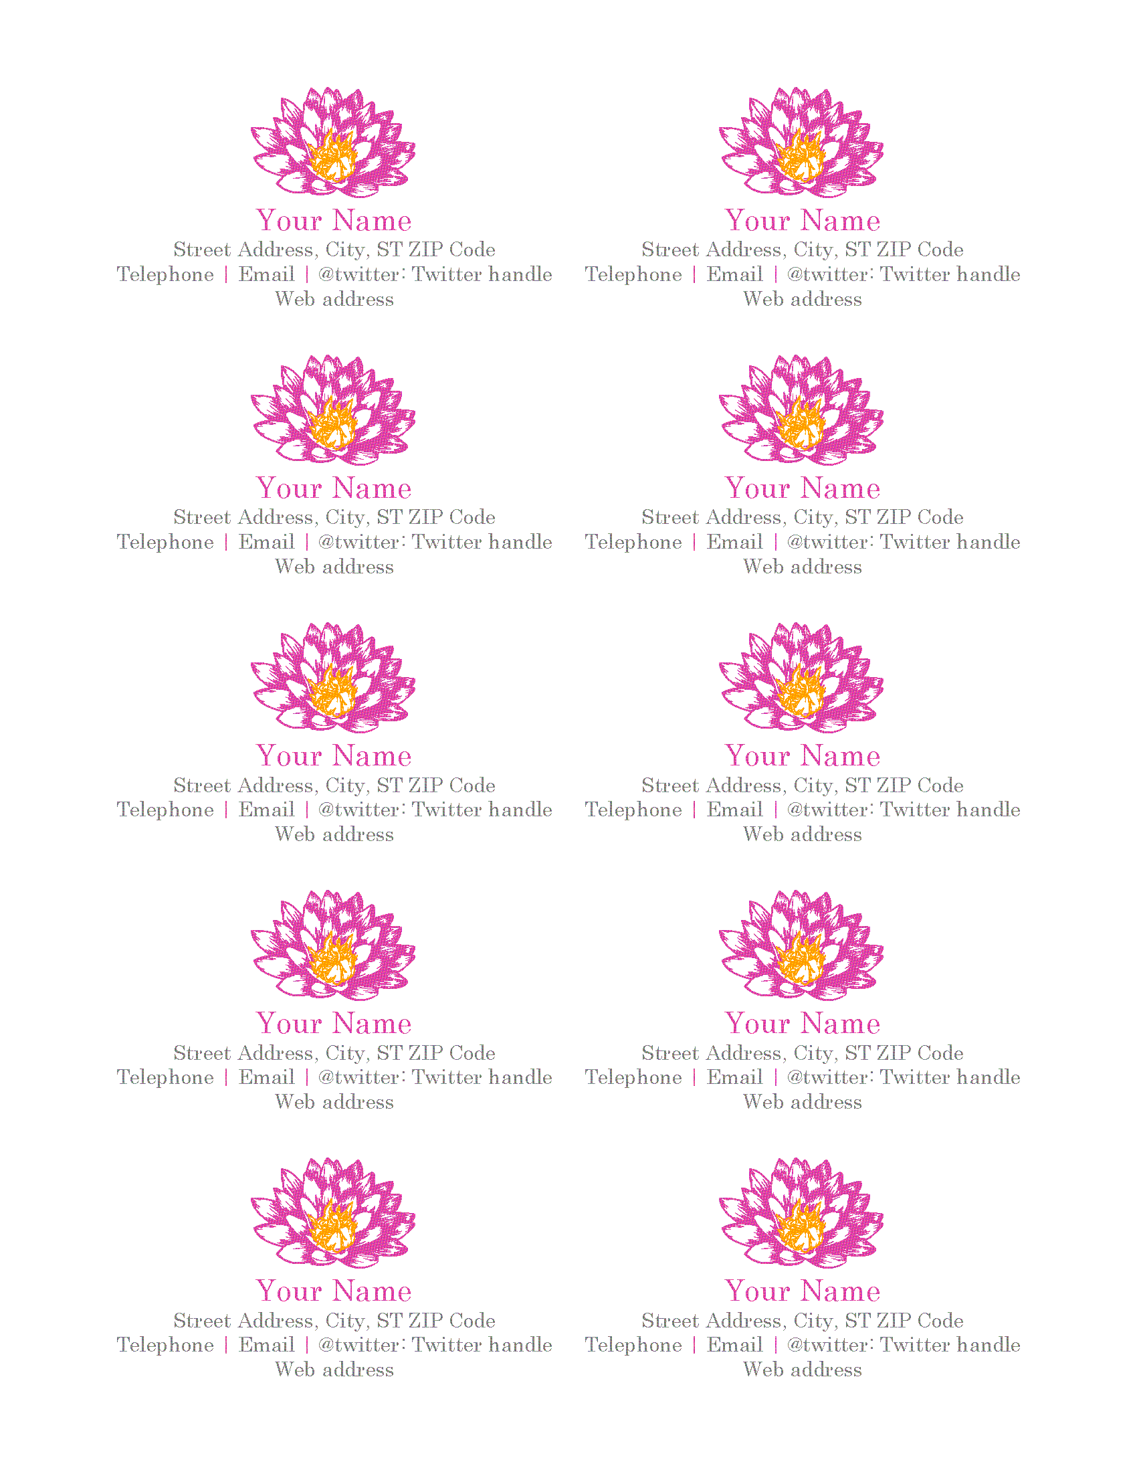  Use this accessible, floral business card template to create unique professional cards of standard 3-1/2 x 2 inches size.  Download template | Event postcards  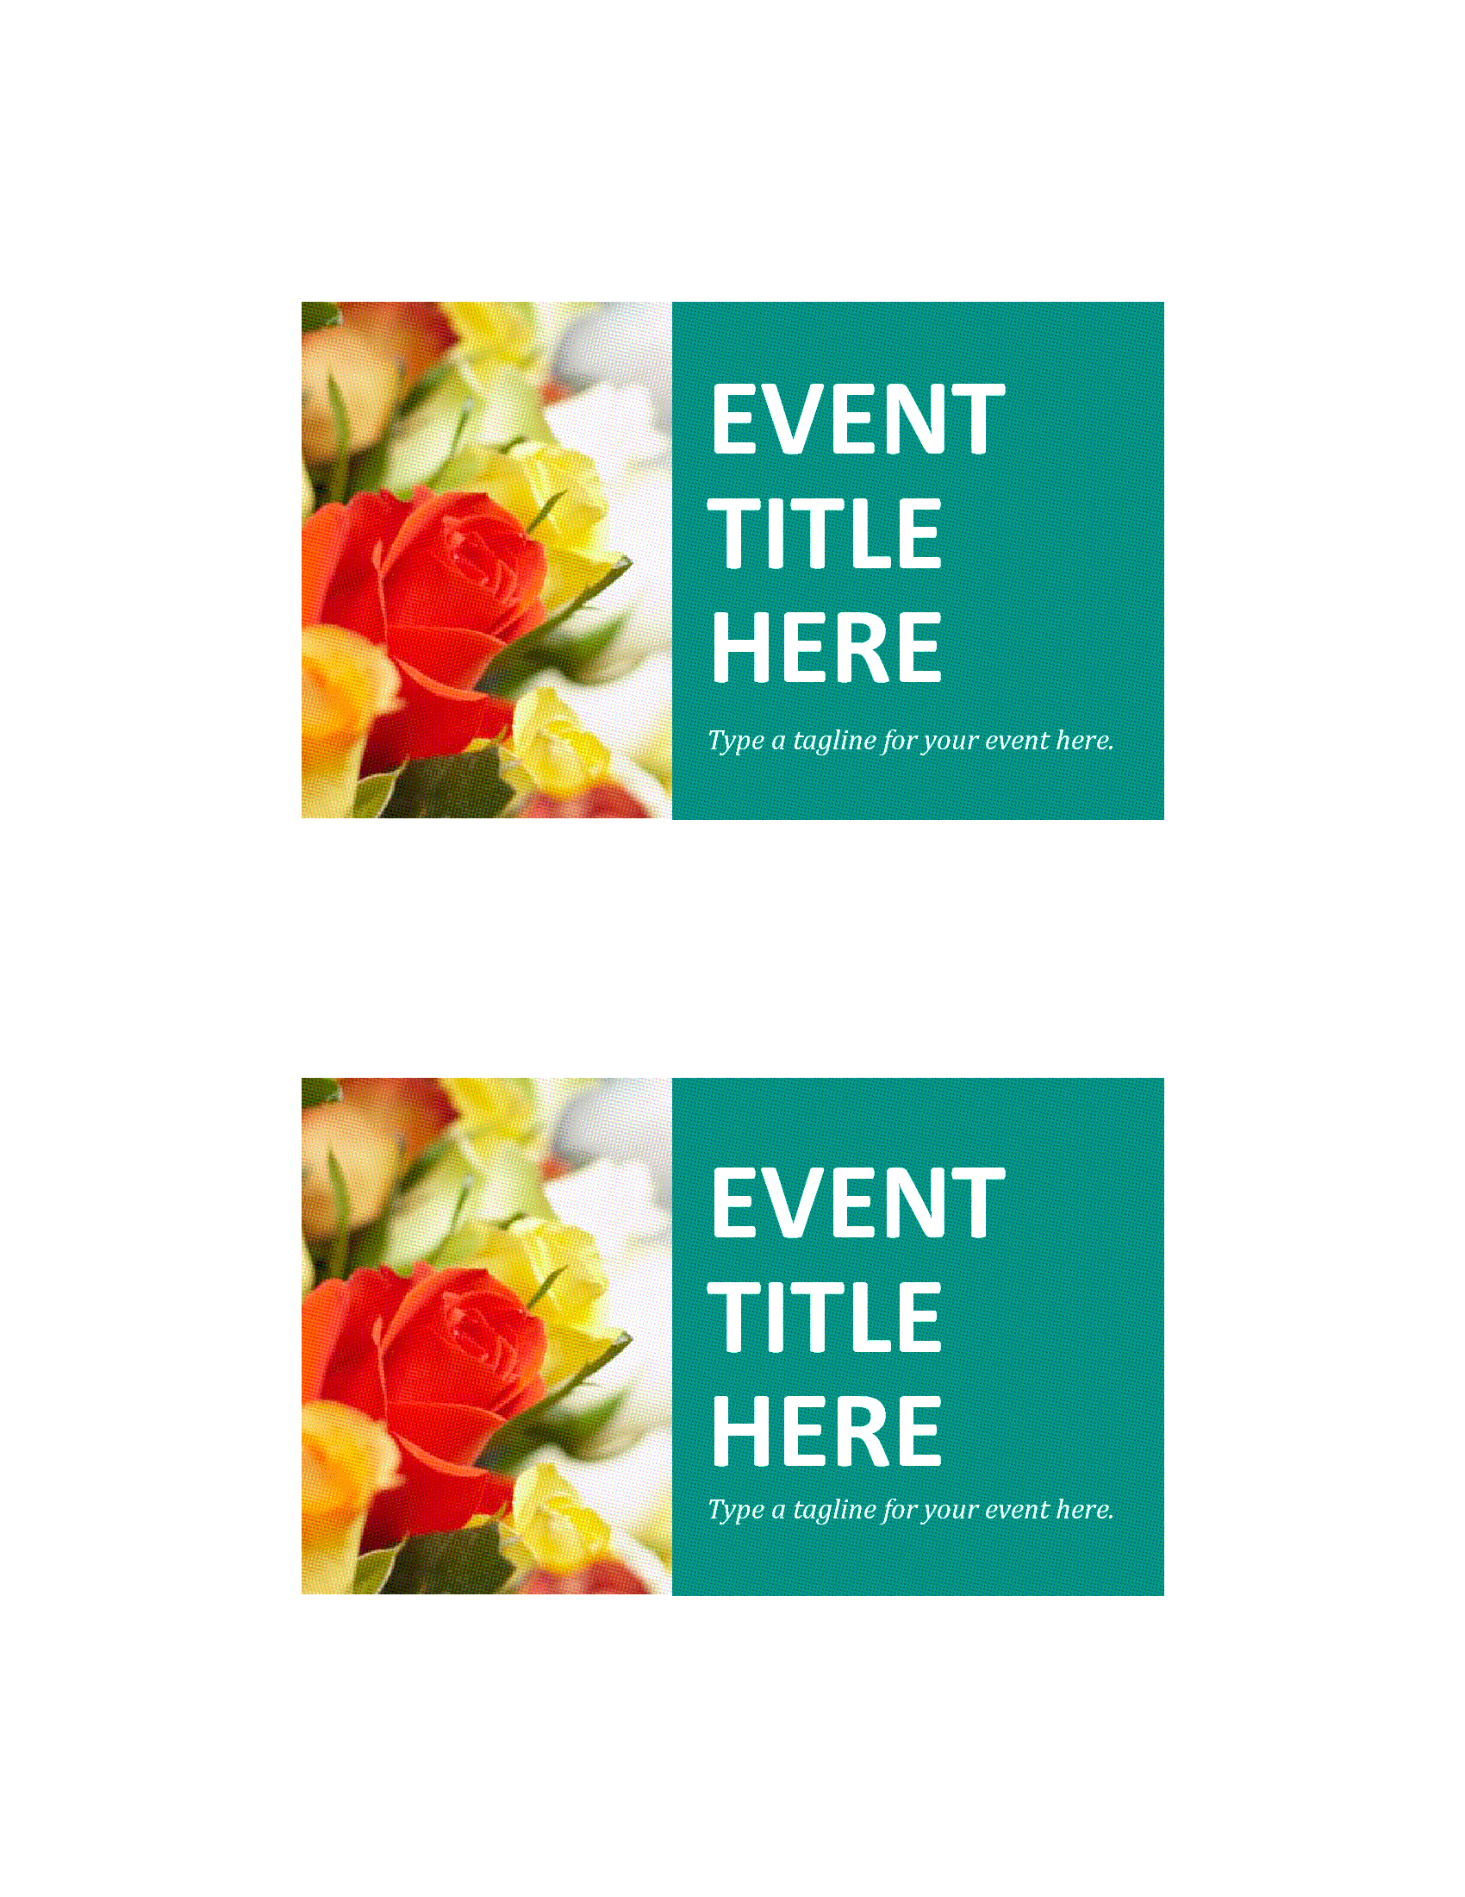  Personalize this accessible and handy postcard template to announce an upcoming sale or grand opening event.  Download template
Appointment cards (10 per page)  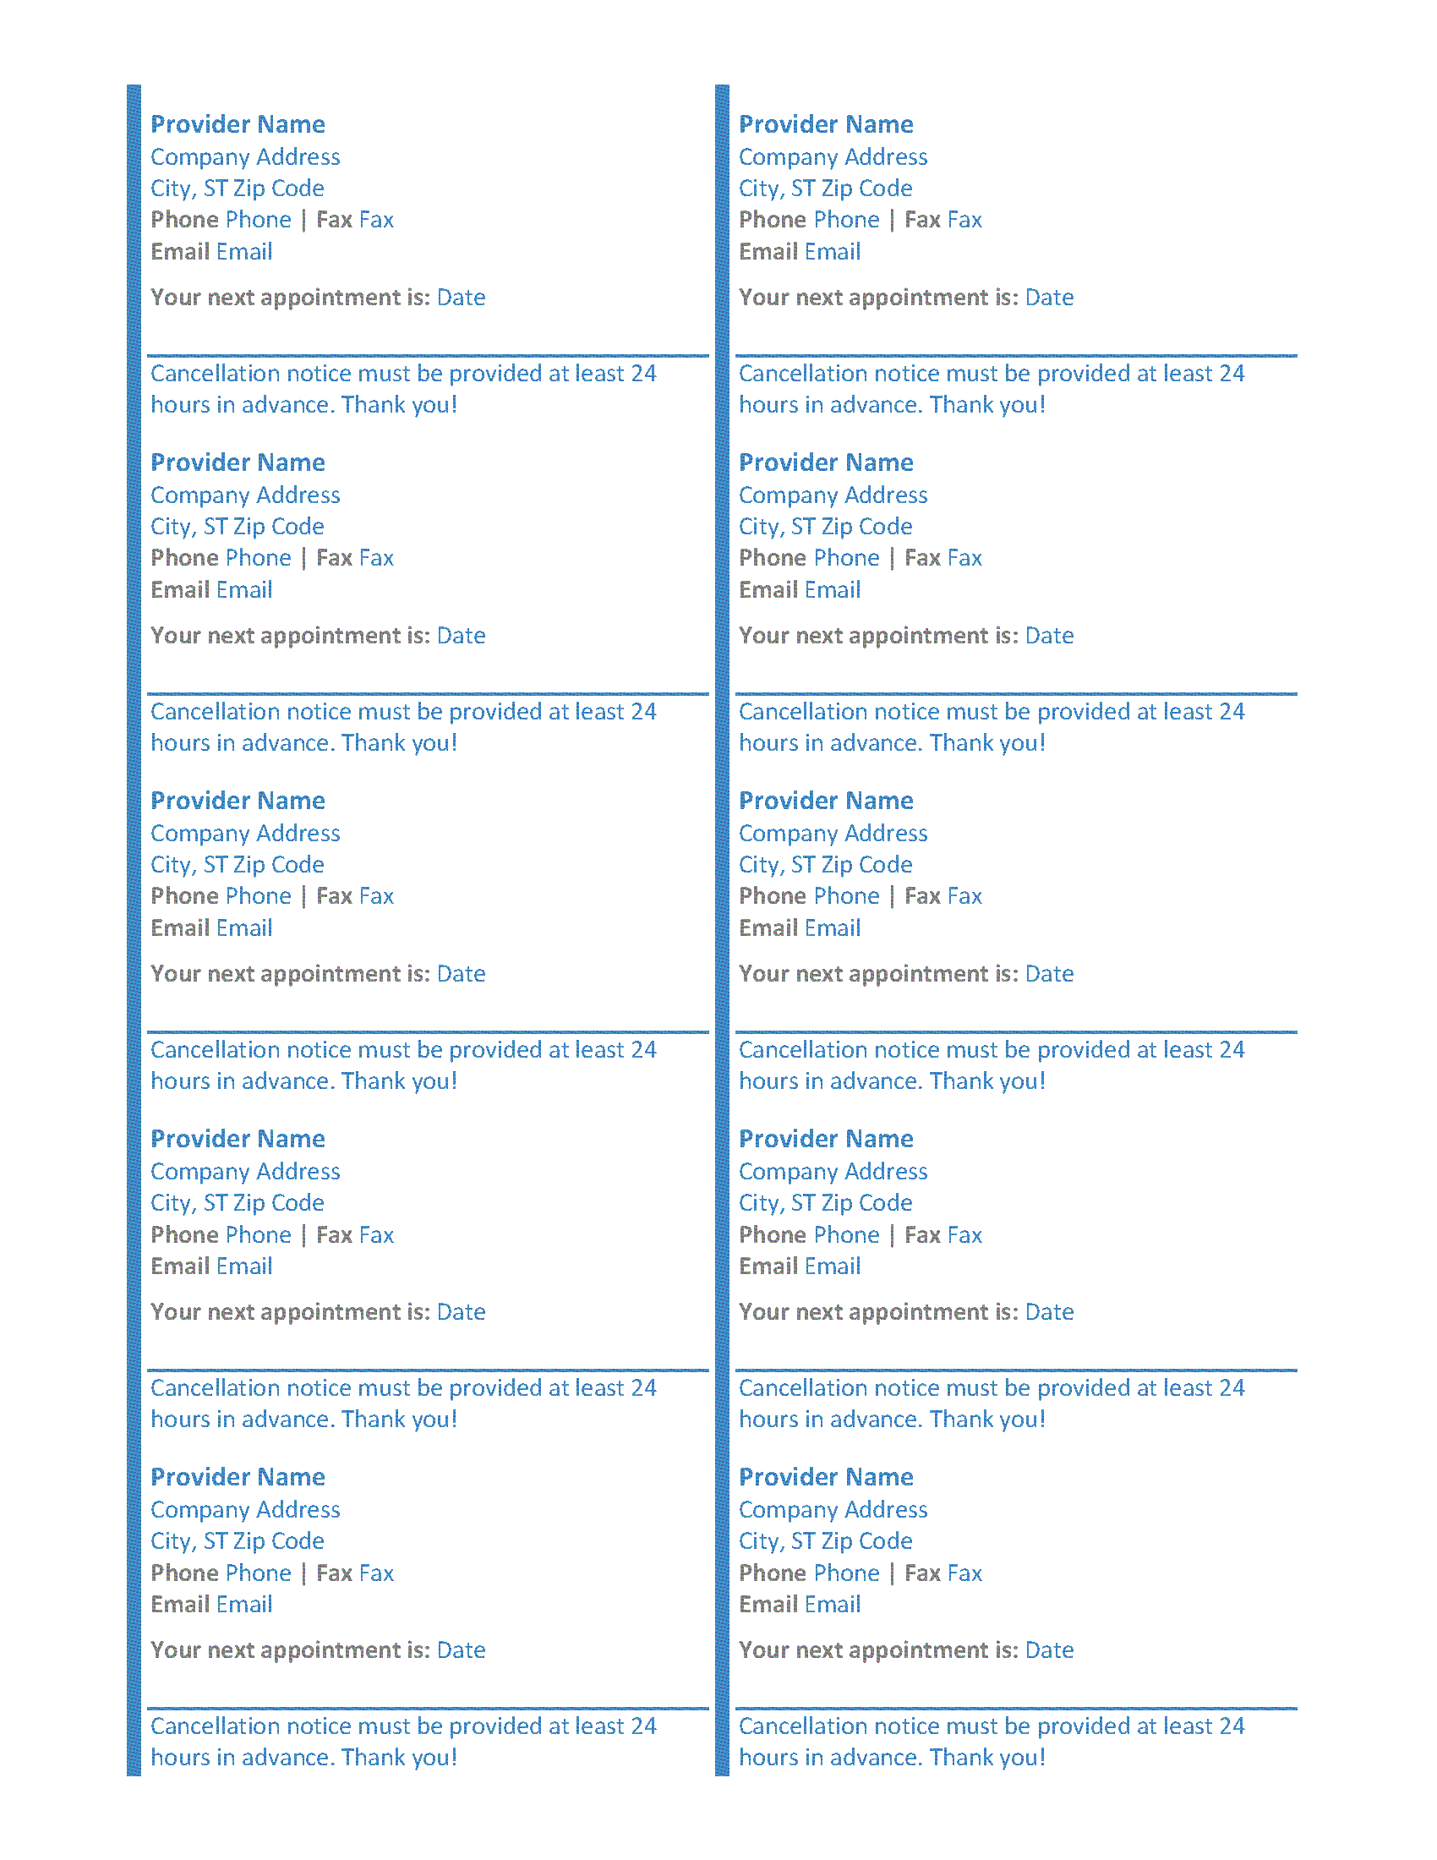  Keep track of upcoming appointments with this accessible template that contains ten 2 x 3.5 inches appointment cards  Download template | Postcard to job candidates when position is closed (4 per page)  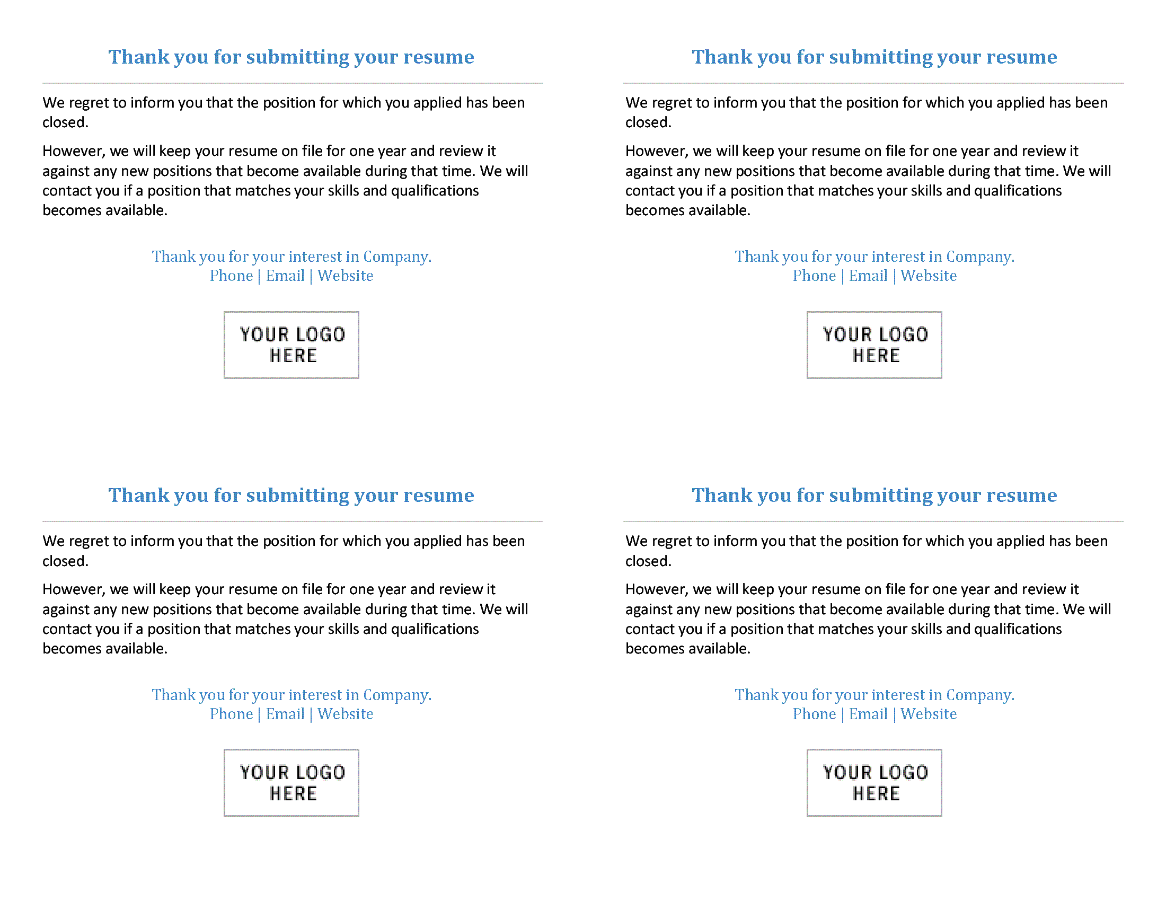  Customize this accessible postcard to send to candidates when the position they have applied for has been closed.  Download template

How to find accessible templates?
Search the term ‘Accessible’ in ‘New’ under the ‘File’ menu, or on Templates.Office.com

How to make content accessible?
Click here to visit the Word Accessibility support page

